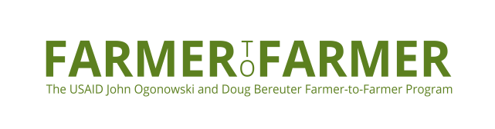

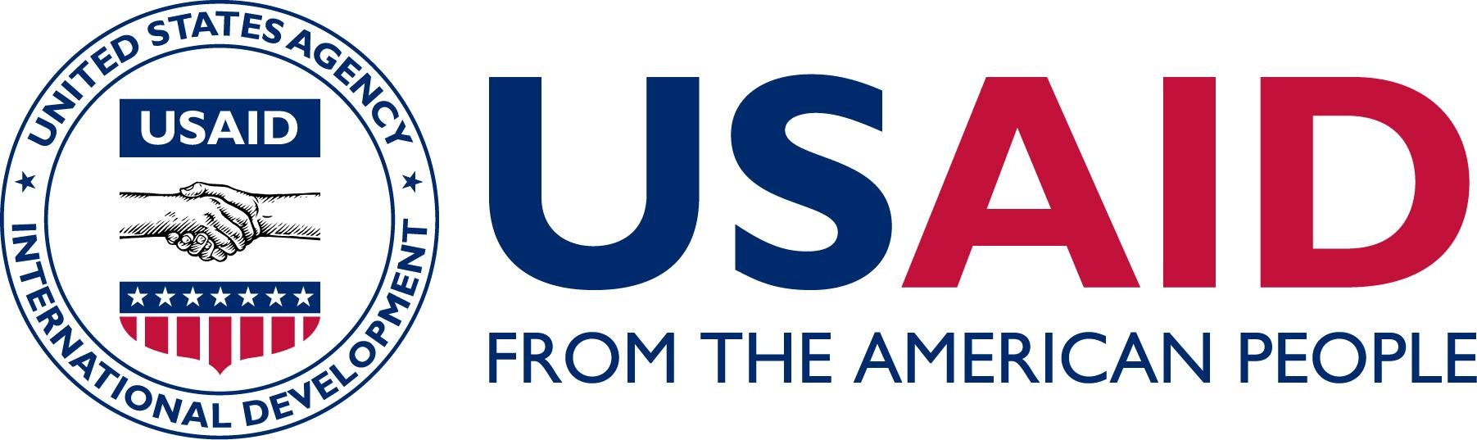

Colombia Farmer-to-Farmer Program
Volunteer Orientation / Information Packet

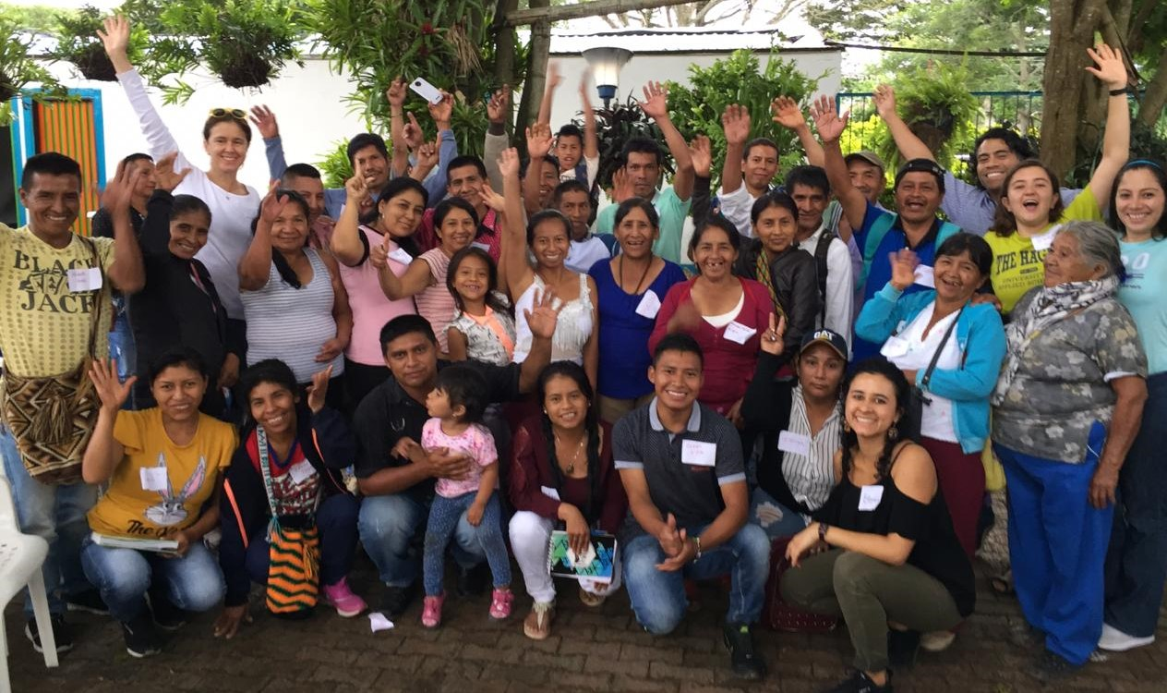

Table of Contents

FARMER-TO-FARMER IN COLOMBIA: 2
PRE-TRIP PREPARATIONS 3
Medical Preparations 3
Travel Advances 3
Pre-Trip Communications with Field Staff 3
TRAVELING IN/OUT OF THE COUNTRY 3
Entry/Exit Documents 4
Arrival at the Airport 4
MONEY, COSTS AND EXPENSE FORMS (PLEASE REVIEW CAREFULLY!) 4
Expense Reports 4
Reimbursable Expenses 5
Lodging 5
Meals 6
SAFETY 6
Farmer-to-Farmer Program Staff – COLOMBIA 7
Farmer-to-Farmer Program Staff – Washington, D.C. 7
U.S. Consulate Santo Domingo 7
Emergency Travel Numbers: 7
ETHICAL RESPONSIBILITY 8
Annex 2 – COLOMBIA Packing Suggestions 9
ANNEX 3 - COLOMBIA COUNTRY INFORMATION 10
Climate 10
Currency and Money Exchange 10
Water 11
Electricity 11
Communications 11
Additional Information 11
What to See and Do 12
MAP OF COLOMBIA 13

Annex 1: Contact List
Annex 2: Packing Recommendation and Suggestions
Annex 3: Information about COLOMBIA

Congratulations on being selected for a Farmer-to-Farmer (F2F) Volunteer Assignment in Colombia!

In this orientation packet, you will find the information you need to prepare for your assignment. We strongly encourage you to review this packet in full prior to your departure and to take a copy with you to Colombia. We are proud of our history of having a safe and satisfying volunteer program. Please keep in mind that your Colombia hosts will be looking after you as if you were a member of their family. Please follow their directions and guidance for a safe and productive volunteer visit.

Farmer-to-Farmer in Colombia:

The United States Agency for International Development (USAID) Farmer-to-Farmer program was established in 1985 by Congress “to provide for the transfer of knowledge and expertise of U.S. agricultural producers and businesses on a voluntary basis to middle-income countries and emerging democracies”. For more information, visit the F2F website: https://farmer-to-farmer.org/

The objective of the Farmer-to-Farmer (F2F) Rural Enterprise Development (RED) strategy in Colombia is to support the development, application, and expansion of financial, commercial and technical agricultural services for smallholder farmers, especially women and youth, with the intention of generating sustainable, broad-based economic growth and job creation.

The program objectives are:
- to expand agricultural sector access to financial services; and
- to increase agricultural sector productivity and profitability, thereby raising incomes and creating jobs.

Volunteers will be deployed to address systemic capacity constraints for farmers and lenders in the country to unlock finance for improved agricultural production; new access to finance will lead to broader utilization of agricultural technologies and increased sales and incomes. Our demand-driven approach will resolve specific market constraints to increase farmers’ and agribusinesses’ access to opportunities for growth through productivity, production efficiency, and market connectivity.

Volunteer assignments will strengthen rural-focused associations and financial institutions to address gaps in technical assistance, management capacity, financial management, financial product design, financial education, access to national and international markets, and data analysis within the target organizations. These areas have been identified as demand-driven based on the needs of potential partners.

The Colombia field staff is highly knowledgeable of both the Farmer-to-Farmer program and the agricultural and environmental opportunities and challenges of the country. They will be your guides while in Colombia and are more than willing to answer any questions you may have. Sergio Correa is the F2F Country Director, Nathalia Vásquez is the Recruiter and Gabriela Villamizar is the Field Officer and together they have experience in agriculture, socio-economic development, and business administration. Dairo Beltrán is the Administrative Assistant.

Please see the staff photos below:

 | 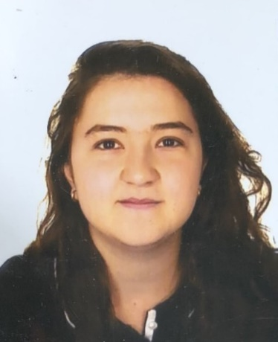 | 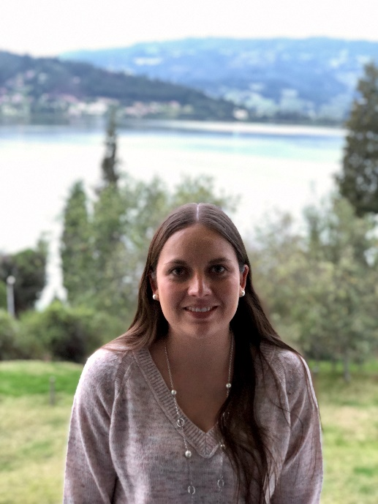 | 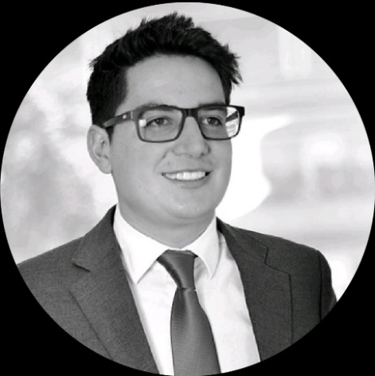
Sergio Correa  Country Director | Gabriela Villamizar  Field Officer | Nathalia Vasquez  Recruiter | Dairo Beltrán  Administrative Assistant

Pre-Trip Preparations

Medical Preparations

First, we urge you to talk with medical professionals regarding any medical conditions you may have, precautions to take, and any vaccinations you may need. You should also visit the Center for Disease Control’s web: https://wwwnc.cdc.gov/travel/destinations/traveler/none/colombia. F2F will not cover the costs of routine or optional vaccinations but may preapprove reimbursements for costs associated with vaccinations or medications necessary for you to travel and carry out your assignment. Please contact your recruiter via email to request written preapproval for reimbursement for such vaccinations or medication costs. Once approved, please save the receipt(s) of your vaccination(s) or medication(s) and submit to Partners HQ in Washington, D.C.

If you are on any prescription medications, be sure to bring enough to last for the duration of the trip. Some medications may be affected by the humidity; ask your doctor if this will be a problem. You should bring the medication in its original bottle to avoid problems at customs. Prescriptions should be packed in your carry-on bag. Discuss with your doctor appropriate prescriptions or supplies that may be helpful for digestive problems, infections, etc.

Medical care for minor illnesses or injuries is readily available, but should you develop a serious medical condition, you may need to leave Colombia. Partners has purchased AIG travel medical insurance for you, which will be valid for the duration of your assignment. If you need medical care for minor injuries or illnesses, our staff will be able to advise you of your options. Due to lack of infrastructure, most clinics will not be able to process the insurance in-country and will expect payment upfront for any services or medications provided. You are expected to pay for treatment upfront and then submit a claim to AIG once you return to the US. Please refer to Annex 2 to read more about this insurance process.

Prior to your visit, please notify F2F staff of any allergies or medical conditions such as diabetes, heart disease, allergies, etc. If you have any dietary restrictions, please let the field staff know in advance so that your needs can be accommodated.

Per Diem
For all full days on travel, volunteers will receive 50% of the government M&IE per diem rate for the particular city (or region for travel where not all specific cities are listed) as listed in the Department of State per diem rate webpage: https://aoprals.state.gov/web920/per_diem.asp

The amount is sufficient to cover (three) meals and incidentals (ie. laundry, international phone calls, water, non-prescribed medicine, toiletries, and other personal expenses) while in country. On the first and last day of travel, volunteers will receive 37.5% of the government per diem rate for the particular destination city (or region for travel where not all specific cities are listed). No additional costs accrued by the volunteer during the assignment will be reimbursed unless they have been preapproved by HQ staff in Washington, D.C.

Pre-Trip Communications with Field Staff
After thoroughly reading these orientation materials, volunteers are free to contact the Field Office in Colombia with questions and/or to discuss details of their volunteer assignment. You can contact the staff directly via email, phone, or Skype. Partners HQ can also facilitate communication (see Annex 1: for contact information).

Traveling In/Out of the Country

Airline tickets to and from the U.S. and Colombia are covered directly by Partners and will be arranged by our Travel Leaders Corporate travel agent. Volunteers are not to arrange flights on their own. Please have a copy of the Contact List (provided below) in your carry-on luggage. This has important phone numbers that should be with you during your travels. If your flight is delayed or canceled, please contact our Travel Leaders Corporate travel agent (see Annex 1) if you need assistance with arranging new flights. Also, call or email the F2F field staff so they are aware of changes in the flight status. Volunteers may not make changes to flights without written preapproval from Partners HQ. Volunteers who make any changes to flights without preapproval will be financially responsible for the cost difference.

Entry/Exit Documents

U.S. citizens do not require tourist visas for stays of 90 days or less. Upon entering Colombia, you will receive an entry stamp in your passport. Your passport must be valid for at least six months beyond your travel dates and must have at least one blank passport page available for the entry stamp.. If you have any questions regarding entry/exit clearance requirements, please contact the F2F program staff. If you have problems upon arrival, please contact the field staff or the other local contacts (see Annex 1).

Baggage
Due to FAA regulations, Travel Leaders Corporate cannot pre-purchase baggage allowances for a volunteer’s trip. You will need to pay for any baggage fees up front, hold on to your receipts, and submit an Expense Reimbursement to Partners of the Americas at the end of your assignment. To anticipate costs for baggage, you should refer to the ticketed itinerary that you will receive once your flights are booked. This information will be listed under “baggage allowance” on the ticketed itinerary. You should submit baggage fee receipts to Partners of the Americas HQ upon return to the US. Note: Partners of the Americas will not pay for overweight baggage fees and/or for more than two luggage check-in.

Arrival at the Airport
Transportation will be arranged to pick you up at the airport. They will have a sign with your name on it. Do not accept rides from others. You can help the person picking you up to recognize you by emailing Partners a picture of yourself prior to your assignment. In the unlikely event that you cannot get a hold of anyone in the local contact numbers, please ask for assistance and call the local contact numbers. If you are not able to reach the staff, the last option is to take an authorized airport taxi (only use licensed taxi companies) to the hotel listed for your first night stay on your in-country agenda.

Money and Costs

Volunteers should expect to bring cash and withdraw Colombia Pesos (COP) from an ATM once in Colombia. Credit cards are not a good source of payment in remote areas. Field staff can help exchange money into local currency. It is important to notify your bank of the international travel prior to leaving the U.S. so there are no issues withdrawing cash from the ATM.

If project-related equipment or supplies are necessary to carry out your assignment, please contact your recruiter via email prior to purchase to determine if the costs for such equipment or supplies can be reimbursed. Only preapproved purchases will be reimbursable.

Lodging
For lodging, volunteers stay primarily in hotels. The selected hotels are preapproved by Partners HQ and the costs will be covered by the Field Office. Room upgrades are considered a personal cost and will not be reimbursed by Partners.

Please be aware of the expenses associated with mini-bars in the hotel rooms, as they will not be covered by Partners but will be considered a personal cost. It is much more cost-effective to buy water and snacks at a corner store or grocery store. Feel free to ask the Field Staff for the locations of corner stores.

Meals
Volunteers will receive a per diem for their own meals and incidentals. Budget meals in Colombia cost $4-$6, mid-range meals are $7-$15, and high-end meals are $15-$25. Please note that when the bill arrives, about 8% is typically added to menu prices as a consumption tax and you are expected to give approximately 10% as a tip. While on your F2F assignment, some meals may be provided to you at no cost by the host organization. However, the volunteer is not required or expected to pay for other people’s meals. If you do so, no costs accrued will be reimbursed.

For health reasons, travelers are advised not to eat food from street vendors or unpasteurized dairy products. Ask your hosts for advice on local foods.

Safety
In Bogotá and major cities, it is safe to walk just about anywhere. However, as with any travel to major cities or foreign countries, there are general safety tips:
- Be especially careful in crowded places like public transportation, large events, and markets. Keep your belongings close to you and don’t leave them unattended.
- Do not use your cell phone, tablet or camera while walking on the street.
- Carry a minimum of valuables, and find different places to conceal them.
- Carry only minimal amounts of cash with you at any one time.
- Don’t walk alone at night, even in safe areas where crime levels are low.
- Please consult the field staff, hotel staff and/or host organization for advise on which areas and regions to avoid.
Volunteers can register with the U.S. State Department before traveling. The Smart Traveler Enrollment Program (STEP) is a free service provided by the U.S. Government to U.S. citizens who are traveling to, or living in, a foreign country and can be useful in case of emergencies. To find out more, please visit: https://step.state.gov/step/.

Volunteer Cell Phone
The field staff will provide each volunteer with a sim card (and if necessary a cell phone) to be used solely for emergencies (i.e. medical, weather-related, safety concern) to contact the field staff, local authorities, or embassy. Volunteers should use their personal cell phones for all other calls.

Annex 1: Colombia Contacts List
It is a good idea to leave these numbers with family members at home.

Farmer-to-Farmer Program Staff – Name of country
Sergio Correa  Country Director, Farmer-to-Farmer  Cell: +57 315 536 1369  Email address: scorrea@partners.net | Dairo Beltrán  Administrative Assistant  Cell: +57 304 328 5127  Email: dbeltran@partners.net
Gabriela Villamizar  Field Officer, Farmer-to-Farmer  Cell: +57 312 283 5492  Email: gvillamizar@partners.net | Nathalia Vásquez  Recruiter, Farmer-to-Farmer  Cell: +57 310 492 6873  Email: farmertofarmer@partners.net
F2F Office Address:  Carrera 11B # 99 - 25  WeWork Office 07-115  Bogotá, 110221 | F2F Volunteer cell phone: +57 315 262 5902
Farmer-to-Farmer Program Staff – Washington, DC
Partners of the Americas
1424 K Street NW, Suite 700
Washington, DC 20005
Phone: (202) 628-3300
1(800) 322-7844
U.S. Embassy in Bogotá | USAID Country Website
Building entrance: Calle 24 Bis # 48-50  Mailing address: Carrera 45 # 24B-27  Embassy phone: +571 275 2000  Consular Section phone: +571 275 4900  American Citizen Services inquiries: ACSBogota@state.gov  Emergency Phone (8am – 5pm, Monday – Friday): +57 1 2752000  After Hours (after 5pm, weekends and holidays) Emergency Phone: +57 1 2754021 | https://www.usaid.gov/es/colombia

Emergency Travel Numbers:
Travel Leaders Corporate  503 644-0333 (main)  Tara Gray – 240-387-4142 (direct)  tgray@tlcorporate.com | Travel Leaders Corporate  After hours and emergency line: (503) 644-0333 (press 3 when prompted) OR (703) 893-2288 (press 3 when prompted)
AIG Assistance Services  (24 hours a day)  Toll free in the US or Canada: (877) 832-3523  Collect outside of the US: +1 (715) 295-9817 | AIG Customer Service  assistance@aig.com

Ethical Responsibility

Volunteers often form a strong bond or friendship with field staff, host families, and/or host organizations. For many, these turn into lasting friendships or professional relationships. Many people become overwhelmed with Colombia’s obstacles to development and lack of resources. We tend to think we can solve this problem by sending money, supplies, and other resources to the country. These resources can have a positive impact. However, if channeled incorrectly, they can also be damaging. If you are asked for money, supplies, resources, etc., please do not make any promises that you cannot fulfill. A broken promise leads to false hope and could tarnish the image of Farmer-to-Farmer and USAID. Two points of ethical responsibility for each traveler are:

- First and foremost, “Do no harm.” That is to say, do not degrade local work practices, local organizations, or the Colombian culture. Keep an open mind and do not think we have the answers to their problems or issues. Instead, volunteers help the people and organizations they work with to discover unique local solutions.

- Do not make promises (i.e., money, supplies, donations, or resources) that you, Farmer-to-Farmer, or USAID are unable to fulfill. Farmer-to-Farmer and USAID have multi-year plans of activities and limited resources with which to carry them out. If you have the time, money, or connections to follow through on your commitments, please consult with the Farmer-to-Farmer field staff on the best way to ensure your assistance has a lasting impact.

Insurance Procedure

Should you require medical care during your assignment, please review the following information:

The field staff will determine the closest clinic/hospital and arrange transportation for the volunteer. If the volunteer needs medical care for minor injuries or illnesses, staff will be able to advise on the different options available.

Due to lack of infrastructure, most clinics/hospitals will not be able to process the insurance in-country and will expect payment upfront for any services or medications provided. The volunteer is expected to pay for their treatment upfront and then submit a claim to AIG once they return to the US. Because credit cards are not a good source of payment in remote areas, volunteers should expect to bring cash to the clinic/hospital. The volunteer should therefore withdraw cash prior to their trip to the clinic/hospital.

Partners of the Americas’ AIG travel insurance includes but is not limited to coverage of medical expenses from accidents or sicknesses, medicines prescribed, accidental death or dismemberment, emergency evacuation, and repatriation. Follow-up treatment for up to 30 days after return to the US may be covered in some cases.

The volunteer must request the doctor write prescriptions for all medication recommended for treatment, even if they do not require a prescription to purchase. Prescriptions and receipt must be saved as proof when filing the insurance claim in order to receive reimbursement. Please make sure to obtain itemized receipts for all services or medications provided. Pictures, if not scanned, of these prescriptions or receipts, must be legible. To file a claim, visit: https://www.travelguard.com/help-center/claims

Partners of the Americas’ AIG travel insurance has a $50 deductible; which Partners of the Americas will reimburse once the volunteer files a claim through AIG.

Filing a claim is not needed if medical costs are below the $50 deductible as Partners of the Americas will reimburse this once submitting an Expense Reimbursement at the end of the assignment.

Annex 2 – Colombia Packing Suggestions

Health related: Please bring: travel insurance information (sent in your congrats packet), prescription medications, copies of prescriptions, a spare pair of glasses, sunglasses, mosquito repellent, sunblock, anti-diarrheal medicine, cold and pain medications, antiseptic towelettes, antiseptic hand gel, first aid items (i.e., bandages, antibiotic cream, anti-itch), tissues, shampoo, and dental supplies.

Clothing: Please bring: your Farmer-to-Farmer hat, bandanas or handkerchiefs, money belt or travel neck wallet, and a bathing suit. Casual work clothes include: jeans, t-shirts, short and long sleeve shirts, walking shoes, footwear for the shower/bathroom, towels, and washcloths. Be sure to bring at least one business casual outfit in the event that you have a formal meeting (i.e., collared shirt, pants, or a skirt/dress). Short pants may be worn on the beach or around the hotel. If you have rubber boots, you can bring a pair during the rainy season. A raincoat and an umbrella will also be useful.

Miscellaneous: Please bring: your orientation manual and contact list, the Volunteer Recommendations Form, and the Expenses Form to fill out during your assignment. Also consider bringing: snacks (i.e., granola bars, trail mix, etc.), a small flashlight, batteries, pens, a spiral notebook, photocopies of your passport (leave one at home, too), telephone numbers and addresses, money for personal expenditures, credit card(s), pictures of family (your hosts enjoy learning about you and your family), camera, an extra memory card for your camera (take lots of pictures!), an alarm clock, a Swiss army knife (in your checked bag only!), a small amount of laundry detergent (although laundry service is available at most hotels), and a good book. Small gifts (i.e., postcards, chocolates, key chains, etc.) that represent where you are from are also fun and a great way to connect with the people you work with.

Assignment-related: For most assignments, bring with you anything you will absolutely need. Do not assume you will be able to buy it in Colombia, although some items are available. If you are teaching, you may want to bring flip charts, markers, paper, pencils, tape, maps, diagrams, photographs, workbooks, etc. Volunteers are expected to travel with and utilize personal computers. Should you require a program computer, please confirm that one is available with field staff prior to your departure. The field office has internet access and there are several internet cafés and hotels in Colombia with wireless internet. Copies of books and materials that you can leave with the field office and/or host organizations are greatly appreciated. Electronic copies of presentations and handouts are very useful, as the staff can then translate them into Spanish for follow-up trainings.

What not to bring: Expensive items, jewelry, etc. Pack light since you will be traveling and having to carry around your luggage. Follow all airline regulations related to carry-on and checked baggage to avoid problems at the airport.

Annex 3 - Colombia Country Information

Quick Facts
Official name: Republic of Colombia
Government: Representative democracy with 4-year presidential terms
Capital: Bogotá
President: Ivan Duque
Location: Colombia is located in Northwestern tip of South America, bordered to the northwest by Panamá, to the north by the Caribbean Sea, to the east by Venezuela and Brazil, to the south by Ecuador and Peru, and to the west by the Pacific Ocean. Colombia has incredibly diverse geography, from rainforests in the south, to lush green mountains in the coffee growing region, to deserts in the north.

Population: 48 million
Official Language: Spanish
Religion: 90% Roman Catholic
Currency: Colombian peso (COP)
Demographics: Mestizo; Afro-Colombian/Afro-descendent; Amerindian indigenous
Major exports: Coffee, cut flowers, coal, petroleum, emeralds
Literacy Rate: 94.6%
Minimum Monthly Wage: 828,000 COP (roughly USD $250) per month
Interesting facts: Colombia is the second most biodiverse country in the world. It is the only South American country with both Pacific and Caribbean coasts. The jungles of Eastern Colombia have 54% of Colombia’s land but only 3% of its people. Colombia has Latin America’s second largest population of African descendants, second to Brazil.

Climate
The climate ranges from tropical to chilly in the Andean mountain, and everything in between. Coastal cities and areas in lower valley regions are typically hot and humid, while high-altitude cities like Bogotá are temperate climates that can range between 6° and 19° C (43° to 66° F).

Due to its proximity to the Equator, Colombia does not have seasons, but rather rainy seasons in which the temperature generally stays constant. The sun is very strong and air conditioning is not always readily available. Be sure to drink plenty of water to keep hydrated and take measures to protect yourself from the sun (i.e., sunscreen, hat, etc.).
Locals will tell you that the weather is unpredictable so always be ready for rain (consider bringing a raincoat and/or umbrella and waterproof shoes).

It is essential to research the weather of your assignment city before arriving; there are areas of Colombia where just driving an hour away can take you to a totally different climate!

Currency and Money Exchange
Colombia’s monetary unit is the Colombian Peso (COP). The typical exchange rate for the past few months has fluctuated between COP 3,000-3,500 to USD 1, but you should check the current exchange rate before arriving.

F2F field staff can assist you in exchanging money at banks or other locations. Keep your exchange receipts if you receive them; as you may need to present them in order to exchange any leftover pesos at the end of your assignment. Credit cards are widely accepted in most tourist areas, but most likely cannot be used in rural areas. Please note that credit cards do tend to charge international fees. The U.S. Embassy advises that travelers to Colombia restrict their usage of credit/debit cards due to increased card fraud in the country. You should try to only use your card in hotels and formal restaurants, and be cautious of who you give your card to in any establishment.

Do not accept help from strangers when withdrawing money from ATMs and make sure the ATM is not altered to avoid card skimming. We also suggest you only carry the amount of money that you think you will use during the day. Keep your money well protected when you carry it in public and keep it locked up or hidden in your hotel.

Food
Colombian food is heavy on meat and starches: potatoes, a tuber known as yuca (also known as cassava), rice and grains. However, the huge array of fruits available make them an important component of the cuisine. In fact, this is often a highlight for international visitors to the country. The granadilla, borojo, curuba and feijoa are just a few examples of fruits we are willing to bet you have never tried outside of Colombia!

Colombian food is quite distinct from Mexican and Spanish food, despite the shared language. Many are surprised to learn that tacos, burritos, paella, tapas and spiciness in general are NOT found here. Colombia has its own rich culinary heritage to enjoy, including bandeja paisa, a comically large plate of meat, sausage, fried pork rind, beans, rice, avocado, plantain and fried egg, and ajiaco, a chicken and potato soup common in cooler climates.
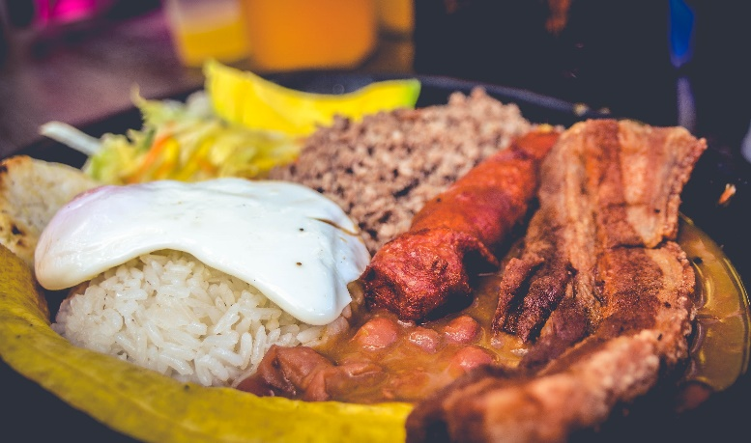
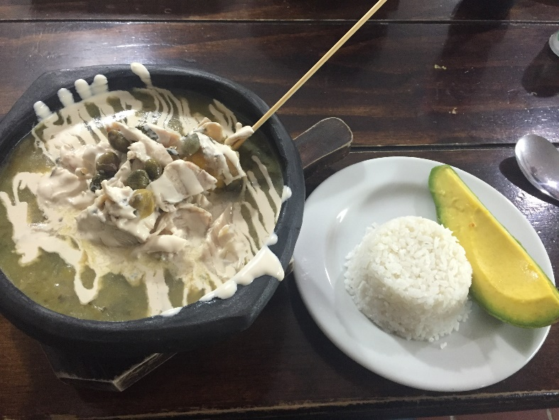
Lunch is typically the largest meal of the day, and throughout the country cheap lunch places, often referred to as corrientazos, serve hearty lunches for around COP 10.000-20.000 (USD $3-6). Dinner, on the other hand, is smaller and normally eaten at home.

Water
Most of Bogotá and some other major cities have the infrastructure to deliver potable (drinkable) tap water. In rural areas and less developed areas of cities, there is not always complete development of sanitation. As a result, it is necessary to drink bottled water. It is recommended that you avoid beverages with ice. Bottled water is readily available in most stores and restaurants throughout Colombia. If bottled water is not available, boil tap water for at least 3 minutes to kill any pathogens.

Electricity
Electricity in Colombia is 110V, with a frequency of 60hz, the following plugs are used:
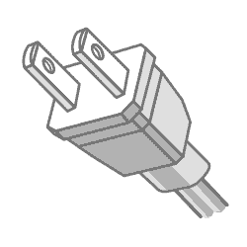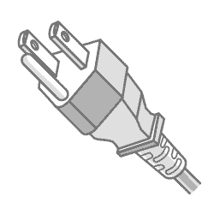

Consider bringing a flashlight as power outages are common.

Additional Information
For more information on Colombia, please visit:
- Colombia – CIA World Factbook: https://www.cia.gov/library/publications/the-world-factbook/geos/co.html
- USAID/Colombia Homepage: https://www.usaid.gov/es/colombia

Language
Spanish is the official language of Colombia, although the government recognizes many indigenous languages (somewhere around 65) as official within their respective communities.

While you may find English speakers in some of the larger or more touristic cities, English is still hard to come by, especially in rural areas and smaller cities. If you don’t already speak some Spanish, begin learning now. Remember: a major objective of this program is intercultural exchange. Immerse yourself!

Below is a list of common words and phrases in Spanish:

English | Spanish | Phonetic Pronunciation
Hello | Hola | Oh-lah
Good morning | Buenos días | Bwen-os Dee-as
Good afternoon/evening | Buenas tardes | Bwen-os Tar-des
Good night | Buenas noches | Bwen-os No-chess
Good bye | Adiós, hasta luego | A-Dee-os, Ah-sta lou-eggo
How are you? | ¿Como está usted? | Ko-Moe Es-tah Ew-stead
Good | Bien | Byen
Pleased to meet you | Mucho gusto | Moo-cho gu-stoh
Thank you | Gracias | Grah-see-ahs
Yes/No | Sí/No | See/Noh
I am from…. | Yo soy de… | Yo soy deh…
Please | Por favor | Por faw-vor
Help me | Ayúdame | Ah-you-da-meh
Excuse me | Perdón | Pear-doh-n
We are looking for... | Estamos buscando… | Es-tah-mos boos-cawn-doh
How much is this? | ¿Cuánto cuesta? | Qwan-toh Qwes-tah
Do you speak English? | ¿Habla inglés? | Ah-blah Ing-les
Do you understand? | ¿Me entiende? | Meh en-ti-en-deh
Can you help me? | ¿Puede ayudarme? | Poo-eh-deh ah-you-dar-meh
Where is the bathroom? | ¿Dónde está el baño? | Dohn-de es-tah el ban-yo
Farm | Finca/granja | Feen-ca/grahn-hah
Irrigation | Riego / irrigación | Ree-eh-go / ee-ree-ga-see-ohn
Seeds | Semillas | Seh-mee-yas
Tools | Herramientas | Err-ah-mee-en-tas
Vegetables | Verduras | Ver-doo-ras
Dairy | Lechería | Leh-che-ree-ah
Integrated Pest Management | Manejo Integral de Plagas | Mah-neh-ho een-teh-gral deh plah-gahs
Greenhouse | Invernadero | Een-ver-na-deh-roh
Fruit Tree | Árbol de Fruta | Ar-bowl deh fru-tah
Livestock | Ganado | Gah-nah-do
To plant | Sembrar | Sem-brar
To harvest | Cosechar | Co-seh-char

What to See and Do

Most assignment-related work will be completed during the week, so volunteers will be able to travel and explore the country on their own on the weekends. The field staff may make recommendations, but is not expected to accompany the volunteer on weekends, therefore the volunteer will be responsible for coordinating their own transportation and plans for the weekends.

The Colombia Ministry of Tourism maintains a website with travel information: https://colombia.travel/en

Also consider borrowing/purchasing a Colombia guide book.

Map of Colombia
